Chief Tournament Directors
Phil Green & Colin Simcox

Refreshments
Coffee , tea and snacks available all day

This event is licensed by the English Bridge Union (Level 4)

Venue
Thornbury Leisure Centre
Alveston Hill
Thornbury
Bristol
BS35 3JB

Directions from M5 (South)
From the M5 Junction 16 take the A38 North towards Gloucester. After 3 miles, at Alveston, turn left on B4061 to Thornbury.

Directions from M5 (North)
From the M5 Junction 14 take the A38 South towards Bristol. After 4 miles, at Alveston, turn right on B4061 to Thornbury.

Directions from M4
From the M4 Junction 20 (M5 interchange) follow signs for M5 (South) but immediately exit (Junction 16) onto the A38 North towards Gloucester. After 3 miles, at Alveston, turn left on B4061 to Thornbury.

All Routes
Coming into Thornbury on the B4061 from Alveston, the Leisure Centre is signposted on the right.

ENTRY FORM
Player 1: ................................................................
Email (or home address if no email available):
...........................................................................
Tel:..........................................
EBU No: .......................................... CODE: ………..
Player 2 :................................................................
EBU No: .......................................... CODE: ………..
Player 3 :................................................................
EBU No: .......................................... CODE: ………..
Player 4:.................................................................
EBU No: .......................................... CODE: ………..
Please let us know your team mates if they have made a separate entry:
...........................................................................

Entry Fees
Full Weekend | £44 per player | Code A
Swiss Pairs | £23 per player | Code B
Swiss Teams | £23 per player | Code C

(PTO)

Entries can be sent by email to:
avongpevent@gmail.com
with payment made by bank transfer (quoting captain's name as reference) to:
Sort code 56-00-05 A/C 21393001

Alternatively, send completed entry forms and cheques (payable to ACBA) to:
Avon Contract Bridge Association (ACBA), c/o Bristol Bridge Club, 99 Oldfield Road, Hotwells, Bristol, BS8 4QQ

Further copies of entry form available at: www.avoncba.org.uk

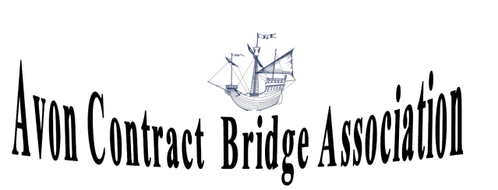
GREEN POINTED SWISS WEEKEND in
THORNBURY near BRISTOL
Thornbury Leisure Centre
Alveston Hill, Thornbury
BS35 3JB
Close to M4/M5 junction
Free Parking on site

Saturday 16th May 2020
13.00 SWISS PAIRS (7x7 Board Matches)

Sunday 17th May 2020
11.00 SWISS TEAMS (7x7 Board Matches)

